Oatley Public School
Letitia St, Oatley, 2223
PO Box 312, Oatley 2223
Phone 9580 5519 Fax 9580 8752
Email oatley-p.school@det.nsw.edu.au

OPS PUBLIC SPEAKING COMPETITION 2023

Thursday 29th June 2023

Dear Parents and Caregivers,
Our annual OPS Public Speaking competition is running in Term 3.
Students will be discussing and learning about the language, features and development of a persuasive speech. They are required to prepare their speech at home and organise it onto palm cards. All students will present their prepared speeches to their class.
Please talk to your child about a possible topic for their speech as they may choose any topic of interest suitable for a school audience. Note: Speeches prepared for the Multicultural Perspectives Competition are not to be used for this competition.

Speeches are marked with equal weighting for both prepared and impromptu (50% each).
See over for details about the competition overview. Additional information about speech preparation guidelines is available on our website (go to the ‘Parent Information’ tab and then click ‘Public Speaking’).
Once the Stage finals have been completed, two finalists from each class will be invited to present at the Oatley Public School Finals evening on Tuesday 12th September 2023.
Important: Students must not edit or change the content of their prepared speech once they have presented it to their class.

Oatley Public School Finals evening times
ES1 speeches: 5:00pm-5:30pm
S1 speeches: 5:30pm-6:30pm
S2 speeches: 6:30pm-7:30pm
S3 speeches: 7:30pm-8:30pm
Important Dates
Date | Event
By Friday 8th September | Stage Finals completed (prior to this date)
Tuesday 12th September | Oatley Public School Finals evening 5pm - 8.30pm
Mid October (exact date TBC) | Public Speaking Georges River Network Finals – location TBC
Tuesday 14th November | Grand Finals – Oatley Public School

Mrs Angela Rozmeta Ms Debbie Hunter
Public Speaking Coordinator Principal
PUBLIC SPEAKING COMPETITION OVERVIEW
The following information provides an overview of the competition in which your child is participating. If you have any queries related to the information provided, please contact your child’s class teacher in the first instance who will then direct you to the public speaking coordinator at the school.
How does the competition work?
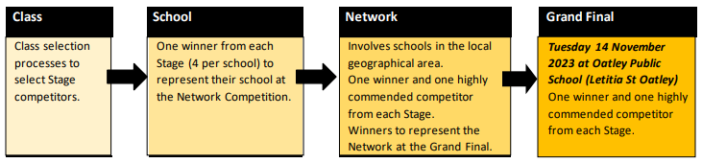
What will the students be doing?
- All competitors are required to deliver both a prepared and an impromptu speech at every level of the competition.
- Both the prepared and impromptu speeches are given equal consideration (50% each) for the overall marking at every level of the competition, including Early Stage 1.
PART 1: Prepared Speech | PART 2: Impromptu Speech
- Early Stage 1 (Kindergarten) = 1 minute  - Stage 1 (Years 1 and 2) = 2 minutes  - Stage 2 (Years 3 and 4) = 3 minutes  - Stage 3 (Year 5 and 6) = 4 minutes | - Early Stage 1 (Kindergarten) = 30 seconds  - Stage 1 (Years 1 and 2) = 1 minute  - Stage 2 (Years 3 and 4) = 1 minute  - Stage 3 (Years 5 and 6) = 2 minutes
- Should be persuasive in nature  - Prepared speeches may be modified between levels of the competition in terms of content and structure but the topic needs to remain the same  - Speech topics are not to come from, or be related to, those of the Multicultural Perspectives Public Speaking Competition for the current year  - Microphones will not be available  - No external aids or props  - Two bells will be rung at the conclusion of the time to indicate that the speaker’s time has expired. A continuous bell will be rung 30 seconds after the completion time.  - Palm cards should be used:  - Early Stage1 and Stage 1 – no larger than a quarter of an A4 page  - Stages 2 and 3 – no larger than an eighth of an A4 page. | - Should be persuasive in nature  - Kindergarten impromptu will be based on an object and they will have 2 minutes of  preparation time  - Impromptus for Stages 1, 2 and 3 will be based on a phrase or single word chosen by the adjudicator on the day and students are able to interpret it as they wish. They will have 5 minutes of preparation time.  - Palm cards will be provided for Stages 1, 2 and 3  - Bells will not be used at the conclusion of time in the impromptu section. A continuous bell will be rung 30 seconds after the completion time.

